**Daffodil International University**  Department of Computer Science and Engineering  Author: [Moniara Akter ] E-mail address: [moniara15-896@diu.edu.bd] Author: [Rasma Akter] E-mail address: [rasma15-854@diu.edu.bd] Author: [Sharmin Sultana] E-mail address: [sharmin15-875@diu.edu.bd] Study programme: [CSE, credit points - 148]Examiner: [Arif Mahamud, [arif.cse@diu.edu.bd](mailto:arif.cse@diu.edu.bd)] Tutors: [Arif Mahamud, [arif.cse@diu.edu.bd](mailto:arif.cse@diu.edu.bd)]Scope: 5934 words inclusive of appendices Date: 2019-03-31

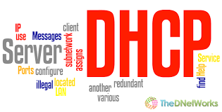

[ Project report]

[Computer Networks Lab-CSE314]

**[DHCP]**

[ Dynamic Host Configuration Protocol]

**[ Moniara Akter----171-15-896 ]**

**[Rasma Akter----171-15-854]**

**[Sharmin Sultana----171-15-875]**

**Abstract**

The routing protocol also specifies how routers in a network share information with each other and report changes. The routing protocol enables a network to make dynamic adjustments to its conditions, so routing decisions do not have to be predetermined and static. In packet switching networks, routing is the higher-level decision making that directs network packets from their source toward their destination through intermediate network nodes by specific packet forwarding mechanisms. Packet forwarding is the transit of network packets from one network interface to another. In this project,we will work on Dynamic Host Configuration Protocol (DHCP) which was defined to facilitate automatic configuration of IP addresses and other network parameters to hosts in a network. We connect DHCP with some dynamic routing protocol like RIP,OSPF and EIRGP.We also connect NAT and ACL with DHCP.

**Keywords:**

DHCP, RIP, OSPF,NAT,ACL, EIRGP,VLAN, Routing protocol , Networking.

.

**Acknowledgements**

All praise and thanks is due to Allah,who enabled us to research on such this project.The lord of mankind and all that exists,for his benevolence and guidance at every stage of our life

we think us almightly God for his blessing showed on us during this period.

we revere the patronage and moral support extended with love by parents,whose financial support and passionate encouragement made it possible for us to complete this project.

We want to thank our subject teacher Mr.Arif Mahmud for the insightful discussion, offering valuable advice, for your support during the period of the project and especially for your guidance during the writing process.

Also to anyone whom We might have forgotten while We were writing these sentences, with all my respect and appreciation.

Table of Contents

Abstract 2

Acknowledgements / Foreword 3

Terminology / Notation 5

1 Introduction 6-9

2 Theory / Related work 10-13

3 Methodology / Model 14-15

4 Design / Implementation 16-21

5 Results 22-25

6 Conclusions / Discussion 26

References 27

**Terminology**

**DHCP Databases:** DHCP server uses two databases

- One database acquires IP addresses manually and binds them permanently to hardware addresses similar to BOOTP

- Other database contains 1 or more blocks of IP addresses (address pools) that are dynamically assigned to clients on FCFS basis i.e assigning on demand.

- when host no longer needs the IP address,it is released & returned

**DHCP leases:**

* DHCP issue a lease for a dynamic IP address that expires at the end of lease time
* After ½ the lease time,client can renew the lease time
* Once lease has expired the client must either stop using the IP address or acquire a new IP address
* If more than 1 DHCP server, each may offer an IP addr to client & client can select the best offer.

There are 3 types of address leases : manual, automatic & dynamic

**Manual lease :** N/W manager explicitly assigns all IP addresses

**Automatic lease :** DHCP server permanently assigns specific IP address and dynamically assigns the rest

**Dynamic lease :** DHCP server dynamically assigns IP addresses for a specific period of time when permanent address is not required

What is DHCP?

DHCP(Dynamic Host Configuration Protocol) is a network management protocol used to dynamically assign an Internet Protocol(IP) address to any device, or node, on a network so they can communicate using IP.

DHCP can be implemented on small local networks as well as large enterprise networks. The TCP/IP Protocols include a DHCP Protocol. It automatically assigns and keep tabs of IP address and any “subnetworks” that require them.DHCP is the default protocol used by most routers and networking equipment.

**Components of DHCP:**

□ DHCP Server

□ DHCP Client

□ DHCP/BOOTP relay agent

**About BOOTP:**

□ DHCP is an extension of the Bootstrap protocol (BOOTP).

□ BOOTP was designed for manual preconfiguration of the host information in a server database.

**Objective of DHCP:**

 DHCP temporarily binds IP address & other configuration parameters to DHCP client & provides framework for passing configuration information to hosts

 DHCP was designed to provide computers with temporary address

 DHCP is well adapted to situation where hosts move from one location to another or are routinely connected and disconnected

 Thus DHCP is mainly used to simplify the installation & maintenance of networked computers.

**DHCP characteristics:**

* **Server**

Several server can be configured for DHCP, coordination not yet standardized (i.e..manual configuration).

* **Renewal of configurations**

Ip address have to be requested periodically, samplified protocol.

* **Options**
* .
* **Big security problems**

**DHCP Configuration:**

Steps to Configure Easy IP

* Configure a named DHCP pool
* Configure network/subnet mask pool
* Configure the default gateway
* Configure addresses to exclude from the DHCP address pool

**Methods of DHCP:**

* DHCP is an application-layer protocol in the TCP/IP model.
* DHCP supports three mechanisms for IP address allocation.
* DYNAMIC ALLOCATION
* AUTOMATIC ALLOCATION
* STATIC ALLOCATION

**DYNAMIC ALLOCATION:**

A network administrator assigns a range of IP addresses to DHCP , and each client computer on the LAN is configured to request an IP address from the DHCP server during network initialization. The request and grant process uses a lease concept with a controllable time period.

**AUTOMATIC ALLOCATION:**

The DHCP server permanently assigns a free IP address to a requesting client from the range defined by the administrator.

**MANUAL ALLOCATION:**

Server allocates an IP address based on a table with MAC address/IP address pairs , which are manually filled in by a network administrator. The DHCP is used simply to convey the assigned address to the host.

**How does DHCP work:**

**1.DHCPDISCOVER:**

It is a DHCP message that marks the beginning of a DHCP interaction between client and server. This message is sent by a client that is connected to a local subnet. It is a boardcast message that uses 255.255.255.255 as destination IP address while the source IP address is 0.0.0.0

**2.DHCPOFFER:**

It is DHCP message that is sent in response to DHCPDISCOVER by a DHCP client.This message contains the network configuration settings for the client that sent the DHCPDISCOVER message.

**3.DHCPREQUEST:**

This DHCP message is sent in response to DHCPOFFER indicating that the client has accepted the network configuration sent in DHCPOFFER message from the server.

**4.DHCPACK:**

This message is sent by the DHCP server in response to DHCPREQUEST received from the client. This message marks the end of the process that started with DHCPDISCOVER. The DHCPACK message is nothing but an acknowledgement by the DHCP server that authorizes the DHCP client to start using the network configuration it received from the DHCP server earlier.

**5.DHCPNAK:**

This message is the exact opposite to DHCPACK described above .This message is sent by the DHCP server when it is not able to satisfy the DHCPREQUEST message from the client.

**6.DHCPDECLINE:**

This message is sent from the DHCP client to the server in case the client finds that the IP address assigned by DHCP server is already in use.

**7.DHCPINFORM:**

This message is sent from the DHCP client in case the IP address is statically configured on the client and only other network setting or configuration are desired to be dynamically acquired from DHCP server.

**8.DHCPRELEASE**

This message is sent by the DHCP client in case it wants to terminate the lease of network address it has be provided by DHCP server.Now as we know about the varies DHCP message ,It’s time to go through the complete DHCP process to give a better Idea of how DHCP works.

**DHCP TABLES**

**DHCP uses two types of database.**

1. **DHCP Network Tables**.

A DHCP network table contains information related to IP address allocation. Each network has a separate network table. The tables, called dhcp_network tables in dhcp.

A network table contains the following specific information:

* Ip address, both assigned and unassigned.
* Client identifier (for assigned records only)
* Lease expiration time
* Flag that indicates the type of lease:

Dynamic, permanent, manual, unusable or BOOTO only

* Name of the dhcptab configuration macro for each IP address.
* IP address of the server that owns the original client IP address.

**2.The dhcptab configuration Table.**

The dhcptab table contains information related to client configuration. The table is organized as a series of macro definition that contain all of the information necessary to configure a network client.

* A Client gets its configuration when it is assigned an IP address from the network table.
* The micro name associated with the IP address corresponds to a macro name in the dhcptab table.

**DHCP server requirements**

The performer of a server can be enhanced when the server has:

* Multiple CPUs
* Multiple network cards
* High performance hard drives.

**DHCP Security considerations**

To secure DHCP environment ,use the following strategies:

* Implement firewalls.
* Close all open unused ports.
* If necessary ,use vpn tunnels.
* Using mac address filters.
* Disable broardcasting the service Set Identifier (SSID) in wireless networks.

**DHCP server and placement**

The number of DHCP servers need to implement is determined by the following factors:

* Network topology
* Network configuration
* Routing configuration
* Availability requirments of the DHCP servers.
* The network of clients which the DHCP servers are going to service.

**Reliability:**

It provides reliability in several ways :

1.Periodic renewal

2.Rebinding

3. Failover

**DHCP Scope:**

* Super-scope
* Multi-scope

**Super-scope:**

* A range of IP addresses that span several Subnets.
* The DHCP server can assign these addresses to clients that are on several subnets.
* A superscope is an administrative feature of DHCP servers that you can create and manage through the DHCP console.

**Multicast scope:**

* A range of class D addresses from 224.0.0.0 to 239.255.255.255 .
* only one copy of the message.
* (MADCAP) is used to request a multicast address from a DHCP server.

**DHCP Scope Properties:**

* Network ID
* Subnet mask
* Network IP address range
* Lease duration
* Router
* Scope name
* Exclusion range

**Advantage of DHCP**

The main advantage of using DHCP are summarized below:

* There is no need to manually configure each client with an IP address
* Address duplication is eliminated as DHCP automatically tracks IP address assignments
* The DHCP server can detect unauthorized DHCP server on the network.
* Centralized administration of IP configuration.
* Dynamic host configuration.
* Seamless IP host configuration.
* Flexibility and scalability.

**Disadvantage of DHCP**

* Place a DHCP relay on each segment
* Configure routers to forward Bootstrap Protocol (Bootp) broadcast
* The DHCP server can be a single point of failure in networking environment that only have one DHCP server.
* When DHCP server is unavailable, client is unable to access enterprises network
* Your machine name does not change when you get a new IP address
* Uses UDP, an unreliable and insecure protocol.
* DNS cannot be used for DHCP configured hosts

**Model**

As our topic is DHCP, so we will make a network which contains some subnets configured with different Routing protocol (OSPF , RIP_2,EIGRP,NAT,ACL,VLAN ).

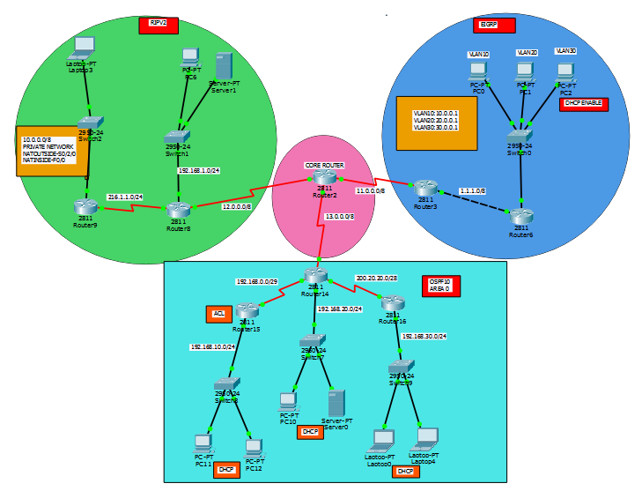

So in our model we have use 8 routers as little like star topology with a canter router#2.Router#2 will be use for connect the subnet using Redistribute command.

As our topic is DHCP all of router#14's,router#15's,router#16's,router#6's devices are DHCP configured.

*Router#3 and Router#6 are configured with EIGRP .Router#6 is connected with switch#0 and some pc.Switch#0 is configured with VLAN.

*Router#8, Router#9 configured with RIP and NAT. Router#8 is connected with switch#1 and server,pc.Router#9 is connected with switch#2 and some laptop. All of Router#8's and Router9's devices are static IP configured.

*Router#14,Router#15,Router#16 are configured with OSPF and ACL. Router#14 is connected with Router#15,Router#16,switch#7,some PC,server.Router#15 is connected with switch#8 and some PC. Router#16 is connected with switch#9 and some Laptop.

**Implement**

As our topic is DHCP, so we will see the details implement of DHCP network and we will describe other network (OSPF , RIP_2,EIGRP,NAT,ACL,VLAN ,) implementation in short .

**DHCP network:**

As our topic is DHCP all of router#14's,router#15's,router#16's,router#6's devices are DHCP configured. For that first we have to make all connects up.

Router#14:

Router(config)#ip dhcp pool test.

Router(dhcp-config)#network 192.168.20.0 255.255.255.0

Router(dhcp-config)#default-router 192.168.20.1

Router(dhcp-config)#exit

Router(config)#exit

Router#15:

Router(config)#ip dhcp pool test

Router(dhcp-config)#network 192.168.10.0 255.255.255.0

Router(dhcp-config)#default-router 192.168.10.1

Router(dhcp-config)#exit

Router(config)#exit

Router#16:

Router(config)#ip dhcp pool test

Router(dhcp-config)#network 192.168.30.0 255.255.255.0

Router(dhcp-config)#default-router 192.168.30.1

Router(dhcp-config)#exit

Router(config)#exit

Router#6:

Router(config)#ip dhcp pool vlan30

Router(dhcp-config)#network 30.0.0.0 255.0.0.0

Router(dhcp-config)#default-router 30.0.0.1

Router(dhcp-config)#dns-server 8.8.8.8

Router(dhcp-config)#exit

Router(config)#exit

Router(config)#ip dhcp pool vlan20

Router(dhcp-config)#network 20.0.0.0 255.0.0.0

Router(dhcp-config)#default-router 20.0.0.1

Router(dhcp-config)#dns-server 8.8.8.8

Router(dhcp-config)#exit

Router(config)#exit

Router(config)#ip dhcp pool vlan10

Router(dhcp-config)#network 10.0.0.0 255.0.0.0

Router(dhcp-config)#default-router 10.0.0.1

Router(dhcp-config)#dns-server 8.8.8.8

Router(dhcp-config)#exit

Router(config)#exit

**OSPF network:**

Router#14,Router#15,Router#16 are configured with OSPF.

Router#14

Router>en

Router#conf t

Router(config)#router ospf 10

Router(config-router)#network 200.20.20.0 0.0.0.15 area 0

Router(config-router)#network 192.168.20.0 0.0.0.255 area 0

Router(config-router)#network 192.168.0.0 0.0.0.7 area 0

Router#15:

Router>en

Router#conf t

Router(config)#router ospf 10

Router(config-router)#network 192.168.10.0 0.0.0.255 area 0

Router(config-router)#network 192.168.0.0 0.0.0.7 area 0

Router#16:

Router>en

Router#conf t

Router(config)#router ospf 10

Router(config-router)#network 200.20.20.0 0.0.0.15 area 0

Router(config-router)#network 192.1

**RIP network:**

Router#8, Router#9 configured with RIP

Router#8:

Router(config)#router rip

Router(config-router)#version 2

Router(config-router)#network 10.0.0.0

Router(config-router)#network 192.168.1.0

Router(config-router)#network 216.1.1.0

Router(config-router)#network 12.0.0.0

Router(config-router)#exit

Router#9:

Router(config)#router rip

Router(config-router)#version 2

Router(config-router)#network 10.0.0.0

Router(config-router)#network 192.168.1.0

Router(config-router)#network 216.1.1.0

Router(config-router)#exit

**EIGRP network:**

Router#3 and Router#6 are configured with EIGRP.

Router#6:

Router(config)#router eigrp 100 Router(config-router)#network 0.0.0.0

Router(config-router)#no auto-summary Router(config-router)#end

Router#3:

Router(config)#router eigrp 100

Router(config-router)#network 0.0.0.0

Router(config-router)#network 11.0.0.0

Router(config-router)#no auto-summary

**Extra:**

**NAT :**

Now we have to configure NAT in Router#9.

Router#9:

Router(config)#ip nat inside source static 10.0.0.2 216.1.1.3

Router(config)#ip nat inside source static 10.0.0.3 216.1.1.3

Router(config)#ip nat inside source static 10.0.0.4 216.1.1.3

Router(config)#ip route 0.0.0.0 0.0.0.0 s0/2/0

Router(config)#int f0/0

Router(config-if)#ip nat inside

Router(config-if)#int s0/2/0

Router(config-if)#ip nat outside

**VLAN:**

Now we have to configure VLAN in switch#0

Switch#0:

Switch>en

Switch#conf t

Enter configuration commands, one per line. End with CNTL/Z.

Switch(config)#vlan 10

Switch(config-vlan)#vlan 20

Switch(config-vlan)#vlan 30

Switch(config-vlan)#exit

Switch(config)#int f0/2

Switch(config-if)#switchport mode access

Switch(config-if)#switchport access vlan 10

Switch(config-if)#int f0/3

Switch(config-if)#switchport mode access

Switch(config-if)#switchport access vlan 20

Switch(config-if)#int f0/4

Switch(config-if)#switchport mode access

Switch(config-if)#switchport access vlan 30

Switch(config-if)#end

Switch#conf t

Enter configuration commands, one per line. End with CNTL/Z.

Switch(config)#int f0/1

Switch(config-if)#switchport mode trunk

Switch(config-if)#end

Router#6

Router>en

Router#conf t

Enter configuration commands, one per line. End with CNTL/Z.

Router(config)#int f0/1.10

Router(config-subif)#encapsulation dot1q 10

Router(config-subif)#ip address 10.0.0.1 255.0.0.0

Router(config-subif)#no shut

Router(config-subif)#int f0/1.20

Router(config-subif)#encapsulation dot1q 20

Router(config-subif)#ip address 20.0.0.1 255.0.0.0

Router(config-subif)#no shut

Router(config-subif)#

Router(config-subif)#int f0/1.30

Router(config-subif)#encapsulation dot1q 30

Router(config-subif)#ip address 30.0.0.1 255.0.0.0

Router(config-subif)#no shut

Router(config-subif)#end

**pc11(ACL)**

Router>en

Router#conf t

Enter configuration commands, one per line. End with CNTL/Z.

Router(config)#access-list 10 deny host 192.168.10.10

Router(config)#access-list 10 permit any

Router(config)#int s0/0/0

Router(config-if)#ip access-group 10 out

Router(config-if)#exit

Router(config)#

**Redistribute**:

we have configured different routing protocols in different subnets and we have a common router Router#2.Now we have to Redistribute to connect different type of routing protocols.

Router(config)#router rip

Router(config-router)#redistribute ospf 10 metric 1

Router(config-router)#redistribute eigrp 100 metric 1

Router(config-router)#exit

The enable ospf to redistribute EIGRP nad OSPF on it.

Router(config)#router ospf 10

Router(config-router)#redistribute rip subnets

Router(config-router)#redistribute eigrp 100 subnets

Router(config-router)#exit

And finally it is time for Redistribute OSPF and RIP in EIGRP.

Router(config)#router eigrp 100

Router(config-router)#redistribute rip metric 1000 100 255 1 15

Router(config-router)#redistribute ospf 10 metric 10000 100 255 1 15

Router(config-router)#exit

And now we are done with implementation and configuration.

**Result**

Now we have to ping in Laptop#0 ( OSPF )for Laptop#3(10.0.0.2) in NAT with RIP.

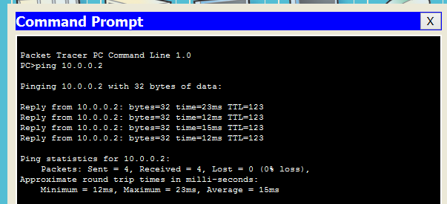

Now we have to ping in PC2(VLAN with EIGRP) for PC10 (192.168.20.3)in OSPF .

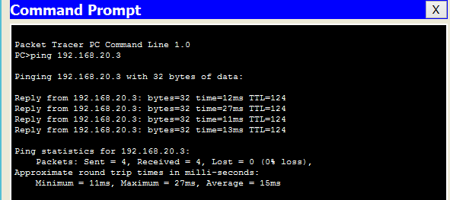

Now we have to ping in Laptop3(RIP) for PC2 (30.0.0.2) in EIGRP with VLAN.

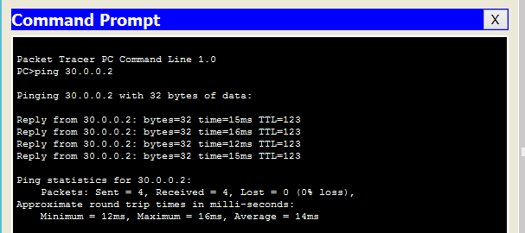

Now lets see the result routing table for the ensure that we have connect network correctly.

Routing table for Router#0

Router# show ip route

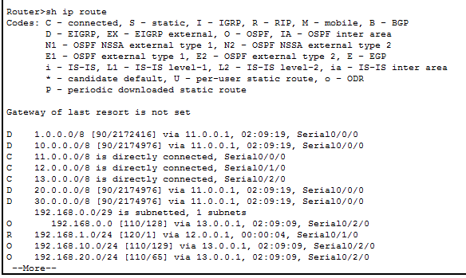

so in the routing table we can see that we have successfully added the routing protocol.

Lets check some extra feature like browse internet from server .Here server ip is 192.168.1.3

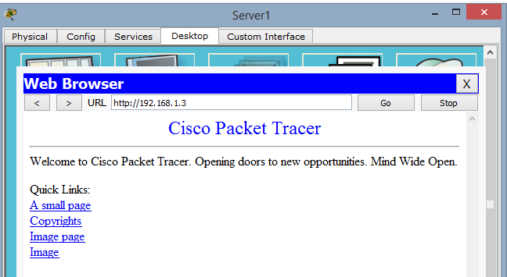

**Conclusions / Discussion**

The report summary of DHCP is, this is a network protocol that enables a server to automatically assign an IP address to a computer from a defined range of numbers configured for a given network. DHCP assigns an IP address when a system is started. It is the best architecture and in similar applications has been very sucessful. The mix of Static and DHCP IP’s is tried and true and fullfils every need stated in the requirements document for this project.

It is true that with these dynamic addressing capabilities, Network Managers save money, time and make their networks more robust and adaptable. It can be concluded from this that even though DHCP now is an integral part of the Internet and an established protocol in network management, it still has to constantly change and evolve, in order to coexist with the changing and evolving world of networking.

During this project, the hardest part was connect different protocols together. We faced many problems and we work hard together and solved all problem.

**References**

1.Enhanced Interior Gateway Routing Protocol - Wikipedia <https://en.wikipedia.org/wiki/Enhanced_Interior_Gateway_Routing_Protocol>

2.Enhanced Interior Gateway Routing Protocol - Cisco

[www.cisco.com/c/en/us/support/docs/ip/enhanced...eigrp/16406-eigrp-toc.html](http://www.cisco.com/c/en/us/support/docs/ip/enhanced...eigrp/16406-eigrp-toc.html)

3.<https://www.youtube.com/>

4.Newest 'networking' Questions - Stack Overflow

<https://stackoverflow.com/questions/tagged/networking>